**NAME: RAJARSHI GHOSH**

**ROLL: 2023000218**

**Date:** 23-07-25

**University Library System (ULS)**

This document presents the development plan of the University Library System (ULS) following the **Software Development Lifecycle (SDLC)** methodology. The system is intended to streamline the management of library resources, improve user experience, and support the university’s library operations.

**SEQUENCE_DIAGRAM: Library Management System**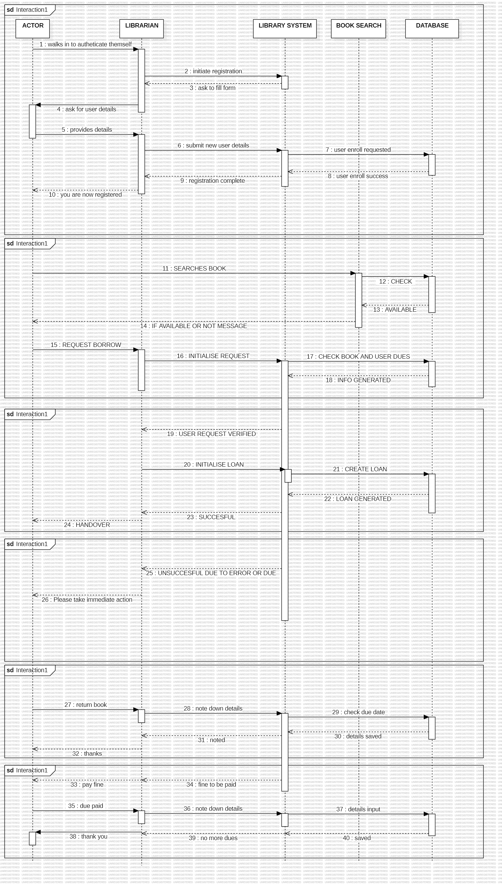

**1. Introduction**

This document provides a functional overview of the Library Management System based on the provided Use Case and Sequence diagrams. It details the system's actors and describes the primary interactions they can perform.

**Actors:**

* **Student/Faculty:** A member of the institution who can register, search for, borrow, and return books, and pay fines. For the purpose of system interaction, they are represented as the primary 'Actor'.
* **Librarian:** A staff member who facilitates user registration, book borrowing, returns, and fine payments.
* **Database Administrator:** A technical user responsible for the direct management of user accounts at the database level, including deletion.

**2. Use Case Specifications**

The following sections describe the system's core functionalities as use cases.

**UC-01: Registration**

* **Actors:** Student, Faculty, Librarian
* **Description:** This use case allows a new Student or Faculty member to be registered in the Library Management System. The process is mediated by the Librarian.
* **Precondition:** The person is a valid member of the institution. The Librarian is logged into the system.
* **Postcondition:** A new user account is created in the system, allowing the user to access library services.
* **Main Flow:**
  1. The prospective user (Actor) approaches the Librarian.
  2. The Librarian initiates the registration process within the Library System.
  3. The System prompts for new user details.
  4. The Librarian asks the Actor for their details (e.g., name, ID number).
  5. The Actor provides their details.
  6. The Librarian submits the new user details into the System.
  7. The System queries the Database to create the user and retrieve associated information (e.g., email).
  8. The Database creates the user record and returns a confirmation.
  9. The System confirms to the Librarian that the registration is complete.
  10. The Librarian informs the Actor that they are now registered.

**UC-02: Search**

* **Actors:** Student, Faculty, Librarian
* **Description:** Enables users to search the library's catalog to check for the availability of a book.
* **Precondition:** The user is interacting with a search terminal or is being assisted by the Librarian.
* **Postcondition:** The system displays the availability and location of the searched book.
* **Main Flow:**
  1. The user initiates a search for a specific book via the Library System interface.
  2. The System forwards the query to the Book Search module.
  3. The Book Search module queries the Database to check the book's status.
  4. The Database returns the book's availability status.
  5. The System displays the result to the user, indicating if the book is available.

**UC-03: Borrow**

* **Actors:** Student, Faculty, Librarian
* **Description:** Allows a registered user to borrow an available book from the library, a process managed by the Librarian.
* **Precondition:** The user is registered and has no blocks on their account (e.g., unpaid fines). The book is available for loan. The Librarian is logged into the system.
* **Postcondition:** The book's status is changed to "On Loan," and a loan record is created against the user's account with a specific due date.
* **Main Flow:**
  1. The Actor presents a book to borrow to the Librarian.
  2. The Librarian initiates the borrow request in the Library System.
  3. The System checks the book's availability and the user's account status.
  4. The System generates the necessary loan information.
  5. The Librarian scans/enters the user's ID to verify their profile.
  6. The Librarian confirms the loan action in the System.
  7. The System sends a CREATE LOAN command to the Database.
  8. The Database creates the loan record, linking the book to the user.
  9. The Database confirms the successful creation of the loan.
  10. The System shows a "Successful" message to the Librarian.
  11. The Librarian hands the book over to the Actor.

**UC-04: Fine**

* **Actors:** Student, Faculty, Librarian
* **Description:** Manages the process of returning a book and settling any associated overdue fines.
* **Precondition:** A user has a book on loan.
* **Postcondition:** The book is returned and its status is updated to "Available." Any fines are paid, and the user's account is cleared.
* **Main Flow (Return and Payment):**
  1. The Actor brings a borrowed book to the Librarian for return.
  2. The Librarian enters the return details into the System.
  3. The System queries the Database to check the book's due date.
  4. The Database returns the loan information.
  5. The System determines if the book is overdue. If so, it calculates the fine and notifies the Librarian.
  6. The Librarian informs the Actor of the fine amount.
  7. The Actor pays the fine.
  8. The Librarian records the payment in the System.
  9. The System sends a command to the Database to clear the user's dues.
  10. The Database updates the user's record.
  11. The System confirms to the Librarian that the user has no more dues for this transaction.
  12. The Librarian confirms the process is complete with the Actor.

**UC-05: Deletion Of Accounts**

* **Actors:** Database Administrator
* **Description:** Allows for the permanent removal of a user account from the Library Management System. This is a privileged operation.
* **Precondition:** The Database Administrator has received an authorized request for account deletion (e.g., student has graduated, faculty has left). The user has returned all books and has no outstanding fines.
* **Postcondition:** The user's account and all associated data are permanently deleted from the system.
* **Main Flow:**
  1. The Database Administrator connects to the system's backend.
  2. The Administrator locates the user account to be deleted.
  3. The Administrator verifies that all pre-conditions are met (no active loans or fines).
  4. The Administrator executes the command to delete the user account.
  5. The System/Database removes the user record and confirms the deletion.

SEQUENCE_DIAGRAM: